## Introduction to AWS IAM

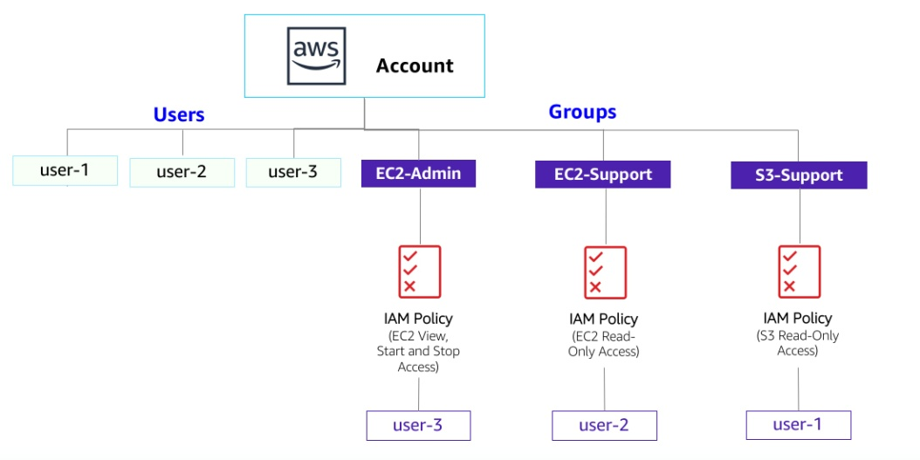

## Build your VPC and Launch a Webserver

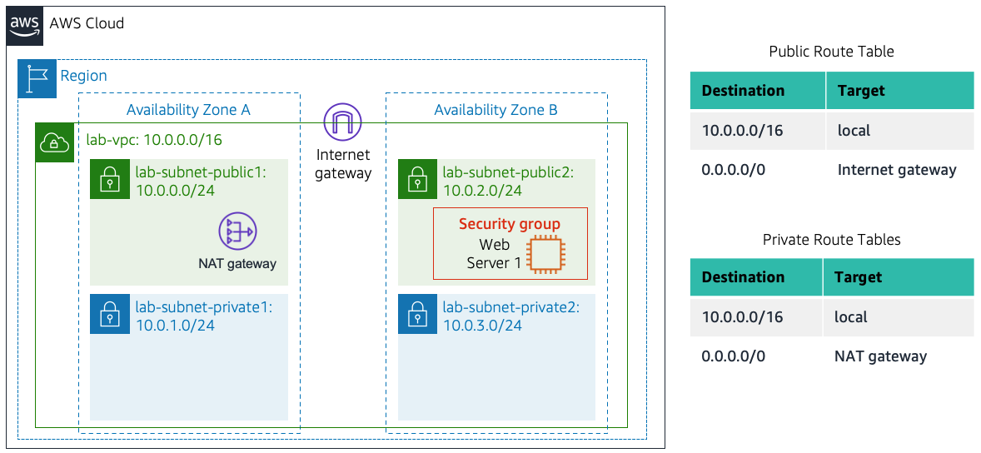

## Introduction to Amazon EC2

## lab-scenario-lab3.jpeg

## Working with EBS

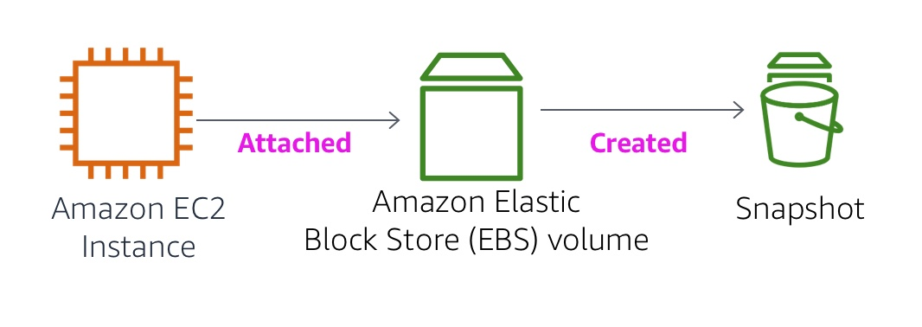

## Build a Database Server

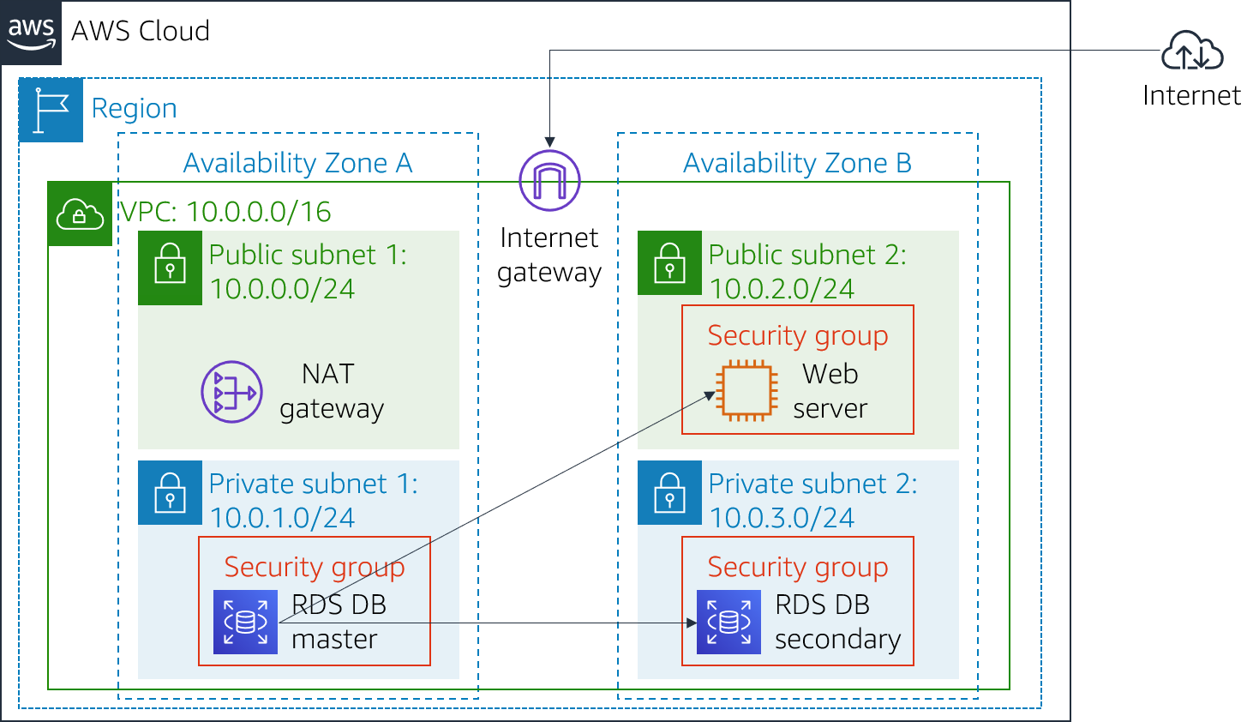

## Scale and Load Balance your Architecture.

